BENDER –SCHMIDT METHOD:
The one dimensional heat equation, namely,
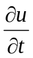 = α² 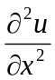where
α² = 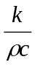is an example of parabolic equation.
Setting α ² =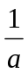, the equation becomes,
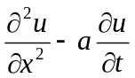 = 0.
Here A = 1,B = 0, C = 0 therefore B² – 4AC = 0.
Therefore, it is parabolic at all points.
AIM :
Our aim is to solve this by the method of finite differences
To solve u_{xx} = au_{t} ......(1)
with boundary conditions,
u(0,t) = T₀ ..…..(2)
u(l,t) = T₁ ……(3)
and with initial condition u(x,0) = f(x), 0 < x <1 ……(4)
We select a spacing h for the variable x and a spacing k for the time variable t.
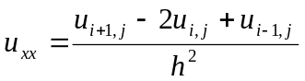
and 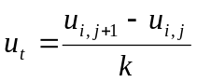
Hence (1) becomes,
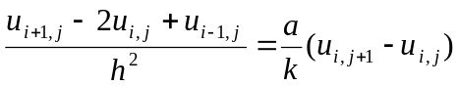
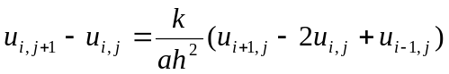
= λ(u_{i+1,j-}2u_{i,j}+u_{i-1,j})
Where λ = 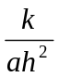
u_{i,j+1} = λu_{i+1,j}+(1-2 λ)u_{i,j}+ λu_{i-1,j}
Writing the boundary condition as u_{0,j} = T₀ .........(5)
u_{n,j} = T₁ ........(6)
nh = ℓ. …….(7)
Where
and initial condition as
u_{i,0} = f(ih) , i= 1,2,… …….(8)
u is known at t = 0
Equation (5) facilitates to get the value of u at x =ih and time t_{j+k}
Equation (5) is called EXPLICIT FORMULA .It is valid if 0 < λ ≤ 
If we take, λ = ,the coefficient of u_{i.j} vanishes.
Hence Equation (5) becomes,
u_{i,j+1} =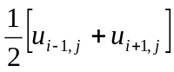
When
λ == ;
i.e., k = 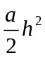
i.e, the value of u at x = x_{i} at t = t_{j+1} is equal to the average of the values of u the surrounding points x_{i-1} and x_{i+1} at the previous time t_{j}.
Equation (9) is called Bender –Schmidt recurrence equation.

1.Solve 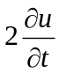 = given u(0, t) = 0, u(4, t) = 0, u(x, 0) = x(4-x). Assume h = 1. Find the values of u upto t = 5.
Sol:
Given, u_{xx} = au_{t} a = 2, h = 1
To use Bender-Schmidt’s equation, k = = 1, λ = =
u_{i,j+1} =
Step-Size in time h = k = 1. The values of u_{i,j} are tabulated below.

t / x | 0 | 1 | 2 | 3 | 4
0  1  2  3  4  5 | 0  0  0  0  0  0 | 3  2  1.5  1  0.75  0.5 | 4  3  2  1.5  1  0.75 | 3  2  1.5  1  0.75  0.5 | 0  0  0  0  0  0

2..Solve = given u(0, t) = 0, u(5, t) = 0, u(x, 0) = x²(25-x²). Assume h = 1. Find the values of u upto t = 3.
Sol:
Given, u_{xx} = au_{t} a = 1, h = 1
To use Bender-Schmidt’s equation, k = = , λ = = 1
u_{i,j+1} = λu_{i+1,j}+(1-2 λ)u_{i,j}+ λu_{i-1,j}
Step-Size in time h = 1, k = . The values of u_{i,j} are tabulated below.

t / x | 0 | 1 | 2 | 3 | 4 | 5
0  1/2  1  1.5  2  2.5  3 | 0  0  0  0  0  0  0 | 24  42  42  39  30  26.6  19.87 | 84  84  78  60  53.25  39.75  35.06 | 144  114  78  67.5  49.5  43.5  32.25 | 144  72  57  39  33.75  24.75  21.75 | 0  0  0  0  0  0  0

